YouTube Insights for Audience

On September 30, 2009, YouTube launched a new video analytics tool called YouTube Insights for Audience, which describes the audience on YouTube based on their demographics. (Image courtesy of YouTube.)

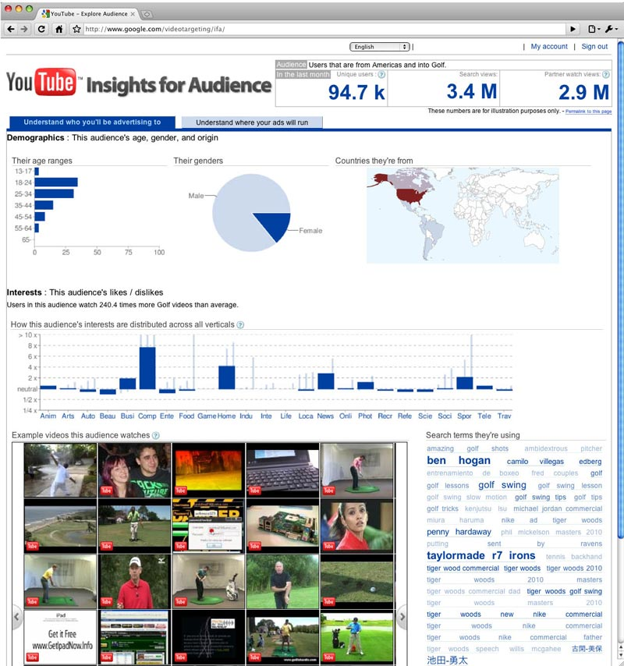

Prior to the launching of this new tool, YouTube provided insights (beginning in March 26, 2008) only to people with YouTube accounts and the videos they upload to YouTube.

YouTube addresses the new tool specifically to advertisers and marketers saying:

“Almost 400 million people watch over a billion videos on YouTube everyday. This gives us a great insight into the viewing habits of the world. With Insights for Audience, we’d like to share some of this information with you.”

Also…

“Using Insights for Audience can help you better understand how your customers interact with YouTube, and might even lead to new discoveries about the overall mindset of your audience.”

So what can the tool be used for?

For one, media and advertising agencies can use the new tool to discover the type(s) of videos users search for based on their country, age, gender and interests. Additionally, the analytics will help agencies to develop better (YouTube) campaign videos that take the interest and viewing behavior of the target group into account.

Using Insights for Audience

Go to http://www.google.com/videotargeting/ifa/buildQuery

If you want to gather information about the behavior of users of a particular gender, click on the tick box corresponding to the Gender you’re interested in.

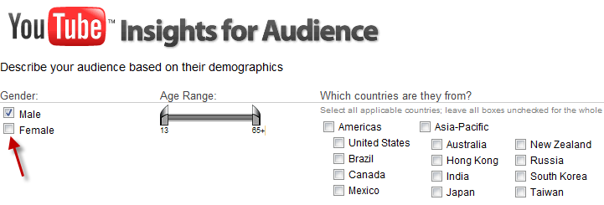

If you don’t specify any gender, Insights for Audience will show you the viewership share of each gender based on the other details of your query.

Under Age Range, adjust the sliders to the age bracket you’re interested in. By default, the age range is set to 13 to 65+ years old.

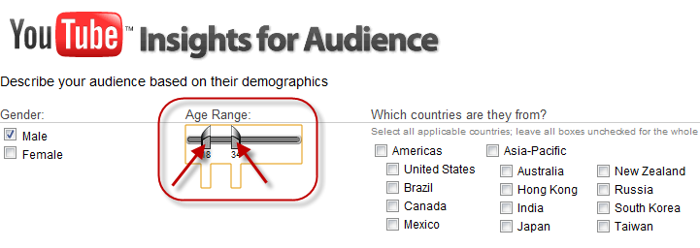

Select the territory/country you’re interested in (you are allowed to select multiple countries/territories).

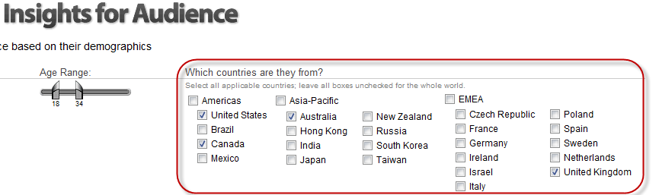

Next, select the interest category that you want the tool to analyze. You’re allowed to choose several. Categories and sub-categories with a right-pointing black triangle indicate that they can be drilled down to smaller sub-categories.

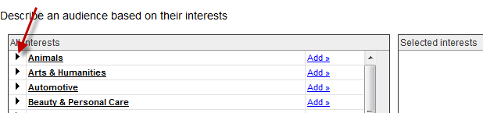
Simply click on them to expand the list.

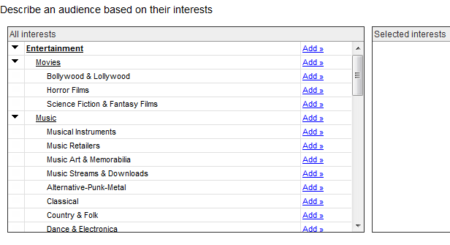

To select an interest, click on the Add link that corresponds to the interest you want to select.

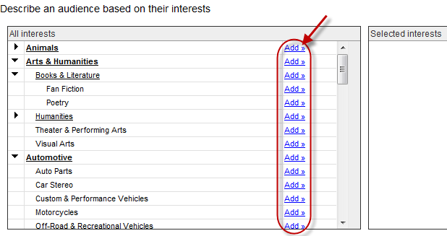

Selected interests will appear in the Selected interests box.

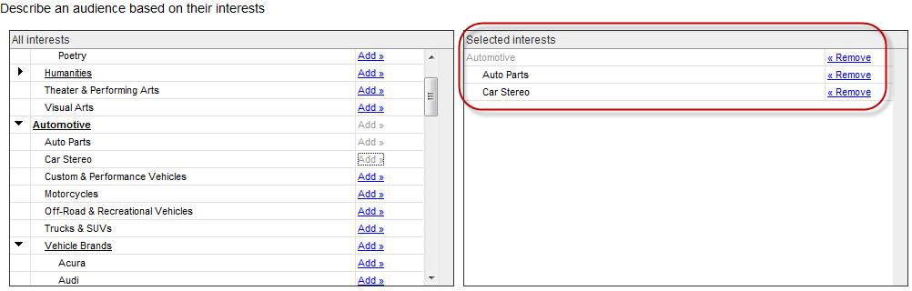

To remove an interest from the Selected interests list, click on the Remove link that corresponds to the interest you want to remove.

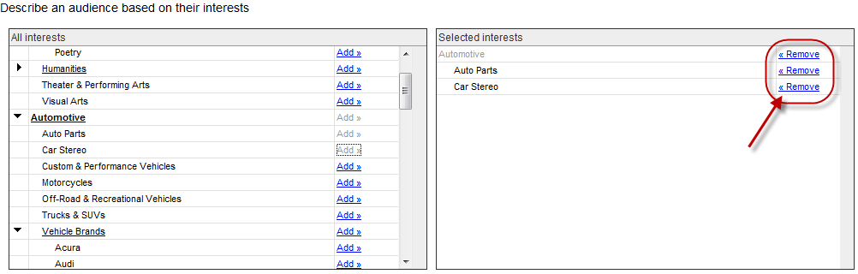

Click on the Apply button at the bottom of the page when you’re done.

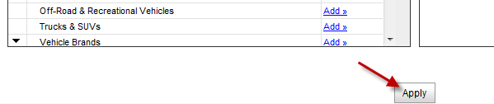

On the results page, you will see a summary of your query on the upper right corner of the page.

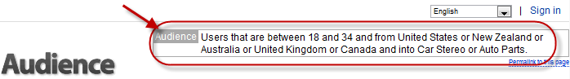
Under Their age ranges you will see the percentage of users that fall under the age range that you have specified. The tool has 7 preset age ranges: 13 to 17, 18 to 24, 25 to 34, 35 to 44, 45 to 54, 55 to 64, and 65 and up.

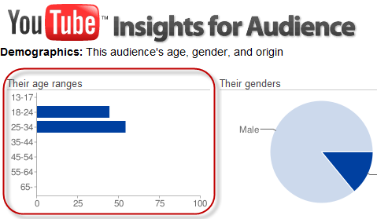

To see a numerical representation of the graph, simply move your mouse pointer over it.

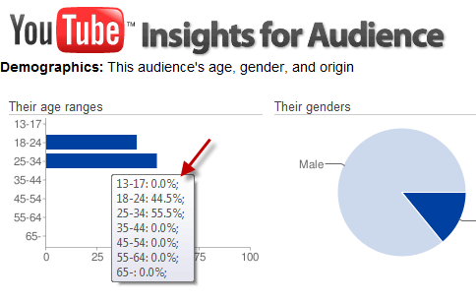

Under genders, if you didn’t select any in your query, you will the graph showing the division of viewership share based on the users’ gender.
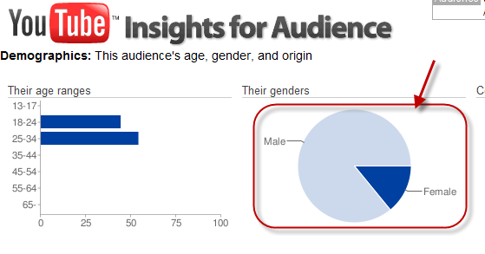

To see a numerical representation of the gender graph, simply move your mouse pointer over it.

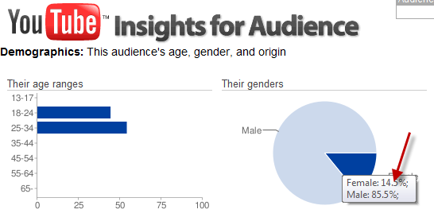

Under Countries they’re from, country/countries in red indicate that more audience are from there compared to the others.

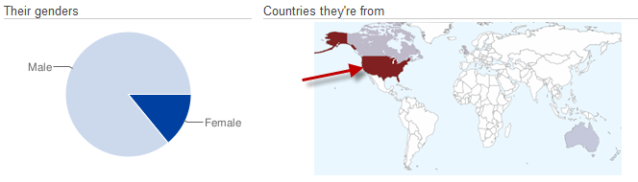
The graph under Interests shows the other interests that your sample demographics are interested in. The higher the bar, the higher the level of interest.

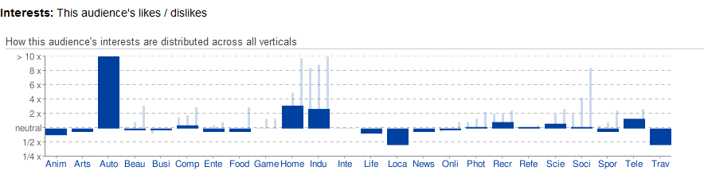

As you may notice in the screenshot of the Interest graph above, you see some thin bars (in a lighter color) extending beyond the thicker bar in some interest categories. Those are the sub-categories that are contained in those categories.

To see those sub-category graphs in more detail, simply click on the interest category/bar that you want to look into. Let’s take Industries, for example:

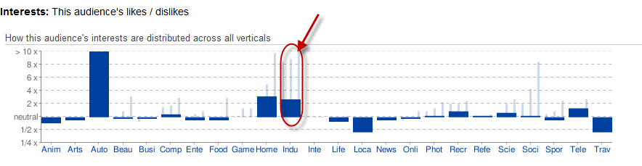

Clicking on that bar will display a new graph showing only the sub categories under the Industries category. Note that dark blue colored bars are clickable and can be drilled down to smaller sub-categories.

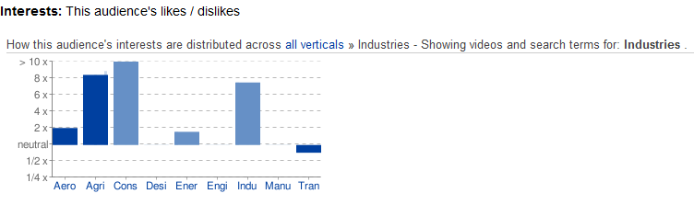
To display the main graph again, click on the all verticals link above the graph.

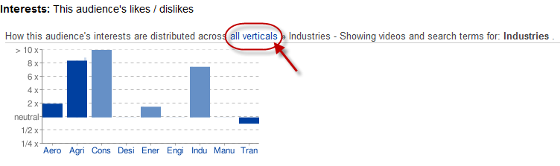

The thumbnails you see displayed in the lower-half of the page are samples of the videos that the demographic you sampled are watching. You can see more by clicking on the arrow on either side of the video thumbnails frame.

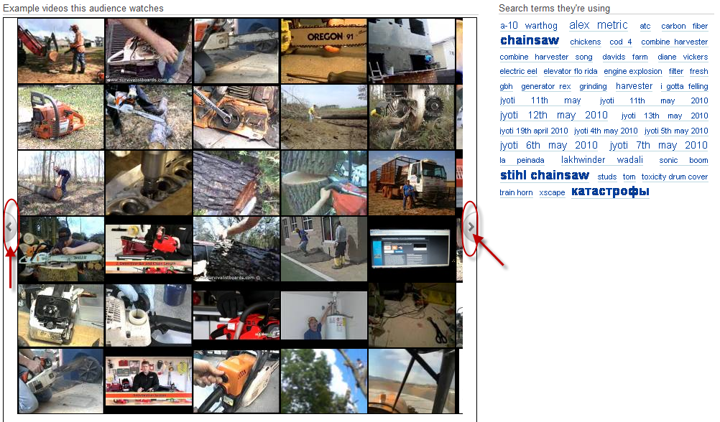

To get a more detailed look at the sample videos, move your mouse pointer over the thumbnail you are interested in.

A pop-up information window will appear showing the video’s number of views, title, and owner/uploader.
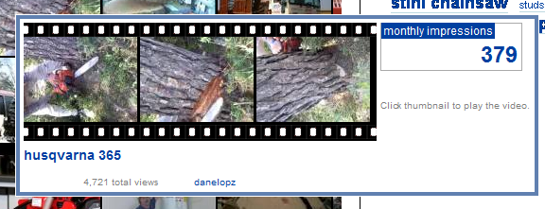

To play the video, click on the thumbnail of the video either on the main sample videos frame or on the pop-up information window.

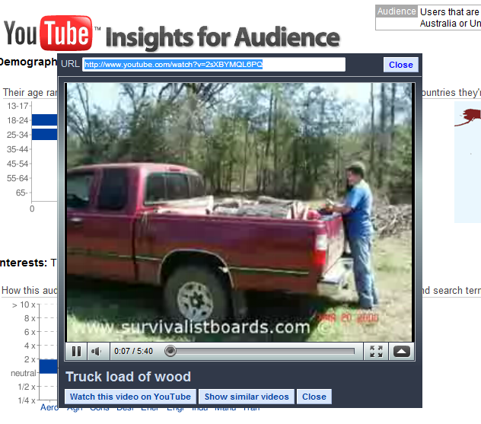

To the right of the sample videos frame is a list of search terms/keywords that your sample demographic is using when looking for the videos they’re interested in.

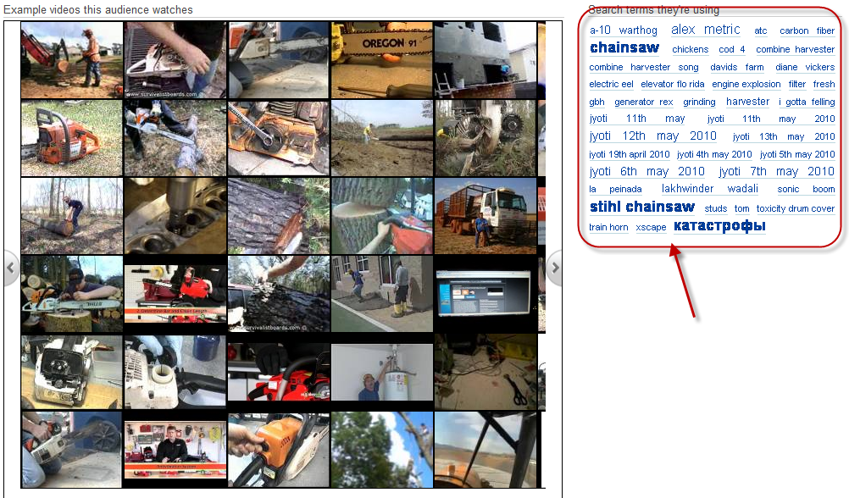

Bonus Content: Best Practices for B2B Marketers

The following best practices are provided by YouTube for B2B marketers to help them reach and better understand their target audience.

- Upload ALL video assets – YouTube tells marketers NOT to hide away any videos. By uploading content to YouTube, you open it up to an audience who will find, watch, share, and distribute it for you. Key tips when uploading video include:

- Give your videos searchable titles, descriptions and tags

- Keep videos and video logs up to date

- Keep content fresh with regular uploads - don’t update everything in one go!

  - Create great content – The key to building an audience is content which is useful and relevant. Create content for the viewer, not just for you. Particularly relevant in B2B communication are:

- Product showcases & Demos – Build momentum for a product by keeping potential customers updated on new and upcoming releases.

- How-to & Expert advice – Build trust with your users by sharing best practices. Video is a highly engaging format and YouTube provides the platform for dialogue.

- Case studies & Editorial support – Promote your work and success stories, showcase your services with results and testimonials. Augment editorial content with embedded videos.

- Conferences / Events – Whether you are hosting, sponsoring or attending an event, raise the profile of your business or sponsorship values via presence or commentary.

- Thought leadership – Demonstrate your industry leadership and put your brand out there as a leader with a strong message to deliver.

  - Be found – With 20 hours of video uploaded to YouTube every minute5, it’s harder than ever to get your videos noticed. Simply posting your videos on YouTube will not suffice: think about what your users search for and where else they might discover your videos. Remember that if you’re doing a viral campaign, even the best material needs an initial push.

- Credit notable speakers and partners in your video description and tags

- Include your website URL in the video description

- Ensure your video is categorized correctly in YouTube

- Consider advertising to get your videos on the search page. Use Promoted Videos to showcase your video against relevant business searches on YouTube. These work in the same way as Google sponsored links, and similar best practices hold true: use relevant keywords and search categories to reach your target audience.

- 23% of YouTube video users watch YouTube videos outside YouTube. Embed your YouTube videos on your site to make them more discoverable and to create a richer user experience. This also lets users know they can find you on YouTube.

- Seed your videos. YouTube boosts social dialogue: conversations follow wherever your videos go. Link or embed your video in editorials, social networks and in tweets.

- Reach your target audience – With so videos out there, how do you ensure your ads are appearing next to the right content and in front of the right audience? As an advertiser, you can place ads on the home page, search pages and video watch pages, and know that your ads will only appear next to premium cleared content.

  - Understand what your audience are watching and searching for on YouTube and target them with precision using YouTube Insights for Audience.

  - Reach your audience with the right type of ad. Consider the effect that your ad will have on the viewer. Pre-roll ads are high-impact and effective at driving brand awareness, in-video and companion ads are interactive and highly engaging; and click-to-play video ads drive up video views.

  - Adapt existing TV ads to run on YouTube. Extend your TV strategy online to run pre-roll ads on short- and long-form premium content on YouTube. Research shows that user attentiveness on YouTube is 1.5 times higher than when watching TV.

- Build a home for your brand on YouTube – Create your own brand space with a YouTube channel. A YouTube channel is a home for your videos that makes it easy for users to find all your content and allows you to control the viewing environment. You can customize it to create a branded destination to engage and build a persistent relationship with your audience in an environment they trust.

- Include links to your site or campaign microsite.

- Take part in the conversation. Encourage comments and subscriptions from viewers. Source other YouTube videos relevant to your message and share them as favorites. Subscribe to other channels that are aligned with your brand message. Listen and react to what they say.

- Make the most of the creative space available to you, including the background, to communicate your brand and purpose. The colors and graphics should reflect your brand.

- Consider upgrading to a Brand Channel to gain additional functionalities, more creative space and drive more traffic. Some additional functionalities include a customizable Channel banner, custom Channel gadgets and a Watch Page banner.

  - Track, analyze and improve – Track your videos’ viewership to understand your audience and how they interact. Armed with this information, you can determine how best to optimize your targeting and your video content, and make sure you are promoting your video to the right audience.

While YouTube Insight provides detailed information about who your viewers are and their level of engagement, Google Analytics tracks the performance of your brand channel as if it were your own site. Analyze how long visitors stay, loyalty, bounce rates, how visitors find your channel, and which sources are driving good traffic.

- Innovate & Integrate – YouTube should be an extension of your site and an integrated part of your marketing strategy. Brands are barely scraping the surface with what can be achieved with YouTube, both creatively and in terms of making the most of the available technology.

